Photo 1
From Tighar site
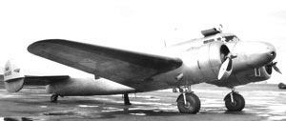

Photo 2
https://www.flickr.com/photos/34076827@N00/4476848192/in/photostream/
says march 14/37
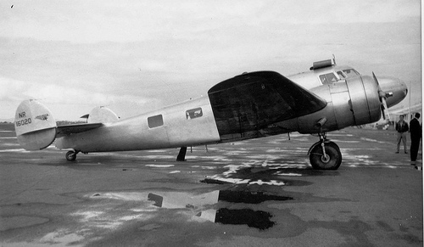
Photo 3
Can’t find record of where I found picture
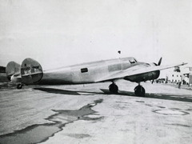

Photo 2 and 3 together
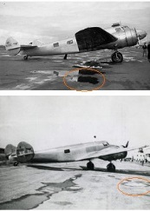

Does anyone else see a lot of similarities in these three pictures when one considers camera position and angle…note circled puddle (ie position relative to wing and shape), features in periphery.
If all pics are indeed different perspectives of the same pose, what happened to the window

